18th February 2019

Renter Activist Day
Venue and arrival

Name and address of venue:
NUS – London HQ
Macadam House,
275 Gray's Inn Road,
London
WC1X 8QB

What time does registration start?
10:30am

Where should I go when I arrive?
Please make your way to Reception at NUS

Are meals and refreshments provided?
Lunch will be provided

What time will the event finish?
16:00

Do I need to bring anything with me?
A pen and paper to make any notes

What should I do if I have a problem?
Please contact events@nus.org.uk

Wi-Fi Code?
Network: NUSGuest Passphrase: hellohello

Where can I store my luggage?
Luggage can be stored at London please speak to reception upon arrival.

Accommodation?
Accommodation is not provided as part of this event. If you require accommodation the night before the closest hotel to London HQ is:
Tune Hotel : Kings Cross, 324 Gray’s Inn Road, London, WC1X 8BU – 0207 713 2050
Please contact them directly to book your stay. Please quote ‘CORP_NUS’ to receive NUS rates.

What about Breakfast and Dinner?
Breakfast and Dinner are not included as part of this event.
There are plenty of places around London and Tune Hotel within walking distance:

Breakfast:
There is a French patisserie next to our London office that sells morning pastries and coffee:

Aux Pains De Papy
Directly next door to NUS
279 Gray's Inn Road
French bakery – pastries, sandwiches and coffee

Niven’s Fine Food Burrito Café
157 King’s Cross Road WC1X 9BN 10 Caledonian Road N1 9DU
Deli – lunch boxes (very good!) Mexican take-away

Costa Coffee
Directly opposite Tune Hotel
257-259 Gray's Inn Road
Coffee, sandwiches, pastries

Dinner: There are a number of restaurants within walking distance from NUS and Tune Hotel.

Pizza Express Nando’s
Clifton House 93-95 Euston Road NW1 2RA 12 - 16 York Way N1 9AA
Italian/Pizza restaurant Peri-Peri chicken

Kitchin Royal Thai Restaurant
8 Caledonia Street N1 9AA 50 Caledonian Road N1 9DP
Buffet – Thai, Chinese, Italian, Indian Thai

Cappadoccia Munchtime/Café Plaka
293 Gray's Inn Road 315 Grey’s Inn Road
Cooked breakfasts and “café” food. Breakfasts, wraps, salads sandwiches, baked potatoes
Pizza in the evenings
The Lucas Arms
Opposite Tune Hotel The Harrison Pub
245 Grey’s Inn Road 28 Harrison Street, WC1H 8JF
Pub food Gastropub

Travel and Directions

Additional travel information can be obtained from the following:
Websites
www.thetrainline.co.uk | www.qjump.co.uk | www.streetmap.co.uk
www.nationalexpress.co.uk | www.tfl.gov.uk | www.nationalrail.co.uk
Telephone
National Rail enquiries: 08457 48 49 50
National Bus enquiries: 0870 608 2608
National Express Coaches: 0990 808 080

Nearest Train Station
Kings Cross / St Pancras – also Euston only a 5-10 minute walk

Nearest Train Station
Kings Cross

Accessible Car Parking
There is on street accessible parking for blue badge holders on the road opposite NUS London Grays Inn Road. There are two bays.

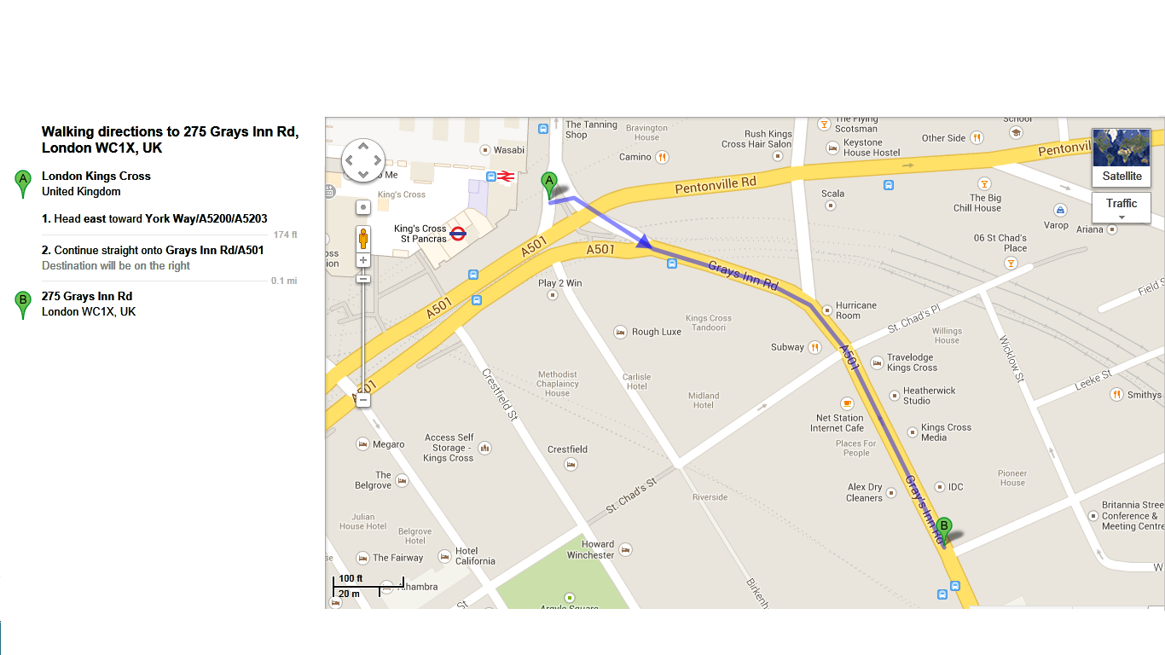
Walking Directions from Kings Cross:

