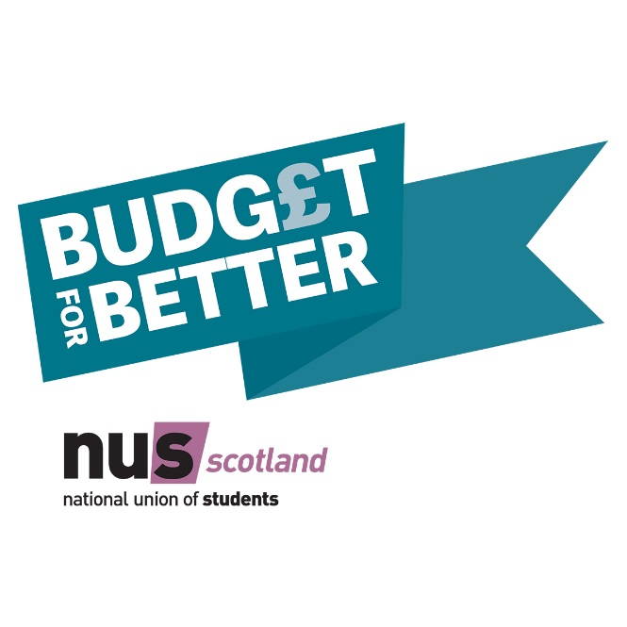
The Scottish Government has rightly made education its priority. With the upcoming Scottish Budget, we’re asking the Scottish Government to make this a reality by supporting a better deal for Scotland’s students. I support NUS Scotland’s Budget for Better campaign and I’m calling for:
- Budget for increased bursary support
- Budget for a better deal for graduates
- Budget for mental health support

Name | Email | Postcode | *
*Please tick if you do not wish to be contacted by NUS Scotland

