Welfare and Students’ Rights

Accommodation Costs – A Campaigning Guide
We know from decades of UK-wide data collection that rents for purpose-built student accommodation go up each year and these rises usually far outpace changes in the private rented sector.

This year’s NUS/Unipol Accommodation Costs Survey showed that rents have doubled in the past ten years with 2012-13 figures reaching an average of £118.49 per week or £4,798.92 per year in institutional accommodation.

This guide looks at some of the issues behind this, and what we might do as students’ unions to campaign on this issue.

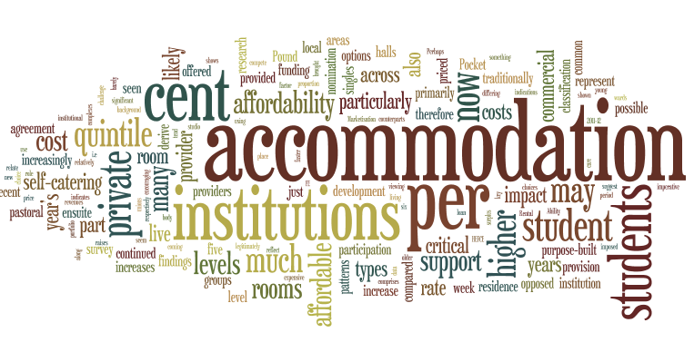

Contents
- Background
- What is the impact on students?
- Our recommendations
- Planning your campaign
- The arguments for affordable accommodation
- Campaign case study

1. Background
The Accommodation Costs Survey has tracked the cost of purpose-built student accommodation provision across almost 30 years. This body of research is critical in being able to formulate an understanding of how much students are spending on their accommodation; often the largest area of expenditure in a student’s budget. This year’s survey has shown that costs have continued to rise much faster than student support and beyond the rate of inflation. This presents a real challenge for affordability and means that students’ budgets are likely to be coming under more strain.

Perhaps the most critical and concerning finding of this year’s report is the most common and traditionally the more ‘affordable’ room types provided by institutions have seen some of the most dramatic increases in price. Self-catering singles, which generally represent the cheapest offering on the part of institutions, are now priced, on average at £97.08 per week – which is now barely cheaper than those offered by private providers. In addition to this, provision of these more affordable rooms has been diminishing as many institutions take older developments out of use or new, higher specification complexes are brought in.

There are also indications that institutions may increasingly be using accommodation revenues to subsidise other areas where they find themselves with funding shortfalls. The sharp rate of rental cost increase, particularly between 2009-10 and 2011-12, coincides with the cuts to higher education funding and it appears therefore that many institutions may have imposed an imperative on accommodation to return a surplus. This raises important questions on whether accommodation is viewed primarily as a pastoral service, or a commercial venture.

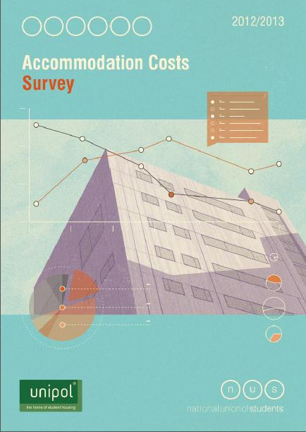

Types of accommodation
This year’s survey saw a continued acceleration in the development of higher end accommodation, with self-catering ensuites now representing 43 per cent of institutions stock, and beginning to dominate their portfolios. This proportion is much higher, at 63 per cent, where there is a nomination agreement in place between the institution and a private provider.

There has also been some development of more expensive studio accommodation on the part of educational institutions (perhaps in a bid to compete with their private provider counterparts), though this still represents a relatively small part of their portfolio.

As a result of these shifts towards more top-end accommodation, there has been a reduction in the availability of more affordable room types, particularly self-catering singles (without ensuite facilities). These now represent just 31 per cent of institutional accommodation and 17 per cent of that provided through a nomination agreement with a private provider.

Marketisation and affordability
Most worryingly, the cost of both self-catering single and ensuite rooms (the two most common and traditionally more affordable room types) has escalated rapidly with them now priced at the same level or even higher than equivalent rooms offered by private providers at £97.08 and £122.81 respectively a week. The affordability of these rooms for many students is now therefore very legitimately under question, particularly when compared to levels of student support which have not seen parallel increases in recent years.

This shift in costs to reflect market rent levels indicates that institutions are increasingly viewing accommodation as a commercial proposition, engaging in aggressive rent-setting and competing with the private sector on amenity levels. The impact of this on affordability for students is something which many institutions seem to have overlooked; along with the concept of accommodation as primarily a pastoral care function rather than a commercial one. Students’ unions can play a key role in encouraging institutions to reconsider their approach.

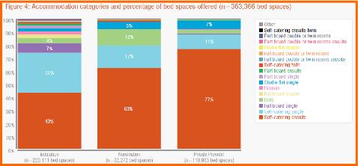

2. What is the impact on students?

Disparity with levels of student support
Rental costs in purpose-built accommodation have increased by 63 per cent in the past six years, compared to just a 25 per cent increase in the maximum rate of student loan for an English domiciled student in the same period. It is possible to derive some evidence on the impact of this from the findings of NUS’ recent Pound In Your Pocket research which can be used to support your local campaign on this issue.

Ability to pay and accommodation choices
Pound In Your Pocket uses POLAR2 classification data from HEFCE which shows how the chances of young people entering HE vary by where they live. The classification comprises five quintile groups of areas ordered from ‘1’ (those wards with the lowest participation) to ‘5’ (those with the highest participation). By looking at differing accommodation patterns across the five quintile groups, it is possible to derive some insight into how options may tend to differ according to s ocial background. Please note these findings relate to English-domiciled students studying in England across HE and FE students.

As you can see from the graphs below, there is significant variance between the residence patterns of students in quintile 1 and quintile 5, with students in quintile 1 being much less likely to live in halls of residence (13 per cent as opposed to 19 per cent) and much more likely to live in their parents’ home (35 per cent as opposed to 21 per cent). It is not unreasonable to suggest that the level of cost associated with living in halls may be a critical factor here and may also impact on their choice of institution (i.e. limiting them to options local to them).

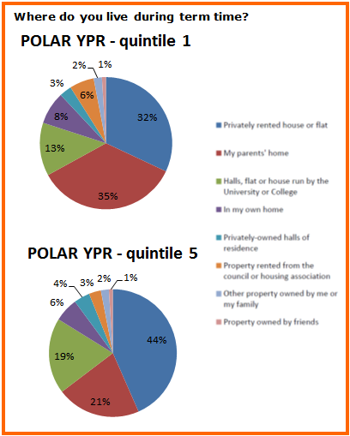

Impact of accommodation cost on financial wellbeing
The Pound in Your Pocket research demonstrated that those who contribute to rent or mortgage payments have much higher levels of anxiety regarding meeting basic living expenses when compared to those who don’t contribute. This is no surprise, given that this is likely to be the largest area of expenditure for those students who have to pay some kind of contribution towards it (whether this is in the form of rent or mortgage payments). 56 per cent of students who make a contribution to accommodation costs regularly worried about this compared with the 36 per cent of students who did not contribute.

Levels of cost
Interestingly, there is no linear correlation between level of accommodation cost and level of financial concern – the highest level of cost is actually associated with the lowest level of concern amongst all but those who do not contribute to rent or mortgage payments at all. Interestingly, the peak of concern is among those paying between £400 and £599 per month, which are standard costs for middle to higher end purpose-built accommodation.

It therefore seems likely that students opting for much higher cost accommodation do so because they are confident in their ability to pay, while some of the seemingly more moderate costs may be causing problems for a large number of students.

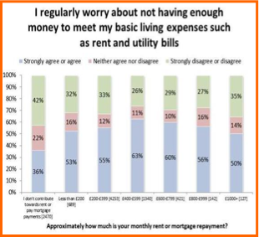
This may be due to either lack of availability of more affordable accommodation or students finding that they have overstretched themselves, perhaps due to not having considered their budget before signing for accommodation or experiencing social pressure to live somewhere they might not be able to fully afford. There is a clear role for institutions to play here in terms of ensuring that affordable provision is available, that allocation procedures ensure no one pays more than they feel able to, and that students are encouraged to consider their budgets at the time of signing for accommodation.

Pound in Your Pocket additionally found that those living in purpose-built accommodation, students in quintile 1 were 50 per cent more likely to work over 16 hours per week than those in quintile 5. This is much more pronounced disparity than across the broader sample, where the difference is 21 per cent. This suggests that elevated rental costs may exacerbate student hardship and push some to take on more paid work, possibly to the detriment of their studies.

3. Our recommendations
Here are some considerations set out by NUS and Unipol for what decision makers should be thinking about when planning changes to student accommodation:

Strategic development and affordability – institutions and partnership working

- Institutions should have a clear commitment to the student experience, ensuring that they employ a balanced pricing strategy based on the importance of choice and affordability.
- Pastoral care and student welfare should be prioritised and there should be a clear description of the care and support package offered to students at the time of letting.
- The role of affordable accommodation in relation to access and widening participation should be acknowledged in institutional strategies. A joined up approach should be employed to ensure that no student is excluded from a residential experience of education.
- Not only should a range of rents be available, but there should be an agreed policy statement on the institutional definition of affordability to ensure that the lower end of the rental structure is genuinely affordable and represents a reasonable proportion of the options on offer.

Transparency

- Where add-on services are provided, they should be clearly explained, free of ambiguity. These additions should also be based on clear demand and evidence of value of money rather than being based on assumptions of student expectations
- Administration or ‘booking’ fees should only cover the cost of actual work undertaken. Institutions should consider why they charge additional fees to students for this particular piece of administration and not for most other administrative support which they give to students during their study lifecycle.
- Where it is felt that upfront charges must be levied, these should be kept to a minimum and, where applicable, should not be required in advance of students receiving their first loan instalment.

Accreditation and standards

- All staff working within accommodation should be familiar with the contents of the relevant code of practice (UUK or ANUK/Unipol) and partnership arrangements should only be undertaken with providers who are members of the ANUK/Unipol National Code.
- Institutions and students’ unions should consider the role they play in improving standards in the broader private rented sector by implementing, managing and publicising local accreditation schemes.

Sustainability

- Students should have access to the information contained in the Energy Performance Certification for their accommodation
- Providers should give each student in their accommodation an estimate of the cost of the utilities they pay, where this is included in the rent to counteract the notion that energy is ‘free’.
- Initiatives to promote a reduction in energy usage should be implemented and the financial benefits of any behaviour change should be returned to the student as a rebate or be used to calculate a reduction in rent prices for the next cohort of students.

Consultation and student engagement
- Students’ unions and students more broadly should be actively involved in the rent setting process, as well as planning for future developments. Proper consultation and engagement will help to ensure that provision is appropriate and suitable for students.
- Student accommodation satisfaction surveys should be undertaken regularly; each year if possible and not less than every two years. Ideally, these should be carried out towards the end of the academic year to ensure a good lead-in time for follow-on actions to be taken. The results should be made publicly available in summary form along the lines of a ‘you said…we did’ format.
- Equality impact assessments should be carried out for all new developments of accommodation to ensure adequate provision for all students, particularly those who have a disability and those with caring responsibilities.

To read the recommendations of the Accommodation Costs Survey in full, please refer to the main report.

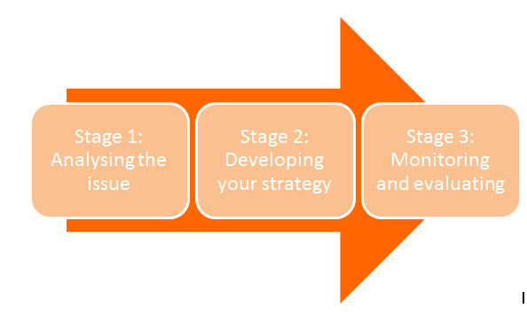
4. Planning your campaign

Stage 1: Analysing the issue
- Investigate: If you’re not already involved, find out what the process for rent setting is at your institution. Often this will happen more than a year in advance, so be prepared to be talk about what rents should be in one or two years’ time. Decision-making on rent prices should be clear, open, transparent, and the students’ union should be consulted on this annually.
- Do your homework: Have a look at the rent levels for various room types at your institution and ask if you can have access to these for the past few years. This will enable you to look at the rate of increase and how this has affected the affordability of accommodation. It would also be useful to find out how many rooms are available at each price level so you can get an idea of the rental structure.
- Go beyond the headline rents: Remember to look at the whole picture. Will there be additional charges on top of the rent that students will need to pay; deposits, booking fees, charges for services, fines? Are these fair, proportionate and do any additional services included represent good value for students? Remember, there is no such thing as a ‘free’ add-on – the rents will cover the costs of any inclusions so it’s important that these are the only things for which there is genuine demand. Also think about the length of the contract – it’s important to know both the weekly and annual rent.
- Investigate the intricacies: See if you can find out in a bit more depth the way that accommodation is funded and funds other parts of the institution – for example, which services revenues from accommodation subsidise such as security and pastoral are, and whether revenue from conference trade is put back into accommodation or whether this goes back into the core institutional budget.
- Compare and contrast: Look at what accommodation is on offer – and what you get for your money – and compare with other institutions. You might want to ask officers and colleagues in students’ unions in the same region as you, or institutions where there is a similar demographic, similar type of accommodation, or with institutions from the same mission group as yours. All of these comparisons will help give you a good picture of how your housing measures up, as well as being able to compare against the national and regional averages within the main Accommodation Costs Survey report.
- Think about different groups of students: What range is there in accommodation cost and type? Some students may be able to afford higher end accommodation, but are there low-cost alternatives too? Are rooms accessible? Is there provision for students with children? If you do any localised research on accommodation preferences, make sure you drill down into the detail of what specific demographics of students prioritise and how their experiences of accommodation differ.
- Consult your members: You are a powerful stakeholder in rent setting and development decisions because you represent accommodation services’ customers. So you should use that knowledge. Ask your membership about what they valued in their accommodation, what they would still value as a top priority from accommodation and what in hindsight would they change? Institutions often base their approach to accommodation on demand from students pre-arrival rather than experiences once they have moved in so having this information at your fingertips could provide useful countering the ‘but everyone wants an ensuite’ argument.

Stage 2: Developing your strategy
- Use your networks: Accommodation officers and finance managers have their own professional networks nationally – they will talk to one another to help them with their decision-making and intelligence gathering. You should too find out what approach other unions are taking to this issue.
- Map stakeholders: Remember that there will be a number of individuals and departments with an interest in student accommodation; widening participation, finance, admissions, student services, marketing. Meet with these people and find out what their perceptions are on cost and provision. Think about how accommodation provision may fit within recruitment or widening participation strategies.
- Be sure of what you’re asking for: Think carefully about what it is that you’re aiming to achieve; are you looking for a rent freeze for everyone or are you targeting specific kinds of accommodation such as that at the bottom end of the rental structure to ensure it is genuinely affordable? By being specific and realistic in what you’re seeking to achieve, you’re more likely to achieve it and be able to work with your institution to establish how this can happen.
- Compromise may be necessary: The art of negotiation is a two-way thing; you will need to compromise on some areas to win in others. It’s important to be clear before you enter any meetings where your ‘red lines’ are, and where you can afford to be flexible.
- Consider your tactics: If you’re seeking to change a fairly technical amendment to an existing pricing strategy at your institution, perhaps chaining yourself to a railing may not be the best first step, equally, if you are facing an implacable vice-chancellor, how do you know when to move from persuasion to pressure? Use what you have gathered from mapping stakeholders to think about power – who are your key targets? Which stakeholders are most able to take action to help you win your campaigns?
Outcomes | Indicator | Target | How to gather data
Balanced pricing strategy adopted by institution | % of management committed | VC to agree to a balanced pricing strategy – policy passed | Copy of policy
Students are less financially constrained by accommodation costs | Anecdotal evidence from talking to students | XX% of students report being less concerned about meeting living costs | Surveys and advice statistics
- Think long term: Try to think beyond the next year or two’s rents, as the long term affordability and suitability of accommodation is going to be determined by a variety of longer term factors. Particularly important are the institution’s commitment to affordability and meaningful student consultation, and their plans for future developments, as well as any planned decommissioning of older buildings. Try to use your work on this subject this year to establish a process for rent setting and consulting on development plans in future, as well as aiming to develop a mutually shared understanding and concrete definition of what your institution views as ‘affordable accommodation’.
- Not as simple as low rent: As must as it may seem like we should be purely aiming for cheaper rents, it’s important to think about standards and services. Sometimes accommodation needs refurbishment, which will incur costs. Sometimes an increase in rent is worthwhile if it delivers better accommodation. Identify where you think essential works are, or where things could be phased? Likewise, what services are valued? Security? Post/parcel collection? Internet? All of these things will have cost implications, you will need to assess whether these are worthwhile costs.
- Look beyong the campus: Where possible also engage with any private providers housing large numbers of your students to try to influence their rent setting and future plans. You might want to consider collaborating with other local students’ unions whose students are housed by the same providers to approach them collectively.

Stage 3: Monitoring and evaluating
- Access your impact: Ensure that you are able to assess the impact of your campaign in relation to the aims and outcomes for students rather than just the outputs of the campaign. These may be less tangible, but will enable you to reflect on the campaign and consider where you’re able to go beyond its current life span.

4. The arguments for affordable accommodation
In order to have the best chance of winning the arguments around affordable accommodation, it is important to be able to make you case on a variety of levels. Below is a summary of the key arguments, which can be made in relation to student wellbeing (the welfare case) and your institution’s financial security (the business case). Made in tandem and perhaps targeted at different parts of your institution, these can help you build an effective and engaging case for your cause.

The welfare case:
- Student support is not rising in line with rent levels.
- Students may be finding it more difficult to find part-time work.
- Many students’ families are likely to be coming under increased financial pressure.
- Accommodation costs are an access issue as they can present a barrier to further study or to choosing particular institutions.
- A lack of affordable options can also cause some students to feel excluded from being able to access a residential experience of education.
- Provision of affordable options should be a part of the institution’s widening participation strategy to ensure this is embedded in all parts of the institution.
- Even if there are bursaries or accommodation fee waivers available, not all students who find covering the costs of their accommodation a challenge will be able to access these. This may particularly impact on some LGBT students who are not able to demonstrate estrangement from their families.

The business case:
- With student increasingly anxious about the cost of higher education, it is likely that, as well as fees, issues such as accommodation costs will start to be taken into account more by students making their choice of institution. Ensuring a broad range of cost and type of accommodation could therefore have a positive impact on student recruitment.
- Research conducted by UKCISA and Unipol in 2010 suggested that accommodation cost is of particular concern to international students, with 59 per cent rating this as a ‘very important’ factor, and 35 per cent considering it ‘important’. Only 6 per cent deemed it ‘unimportant’ or ‘very unimportant’. This was higher than the weighting given to this issue by home students, and was given higher priority than accommodation quality.
- The decline in student numbers this year has already had a significant impact on demand for purpose-built accommodation, as first year students represent the bulk of students choosing this type of accommodation. Private providers now make up 39 per cent of the purpose-built sector (up 22 per cent in the last three years) and are competing with institutions. This year has seen large numbers of empty bed spaces in both institutional and privately provided accommodation – some private providers have responded to this by drastically discounting rents and in many cases undercutting institutional pricing.
- In many cities, even more development is planned for next year, increasing competition further (particularly if student numbers decrease again next academic year). With aggressive marketing campaigns likely from private providers and purpose-built accommodation being much more expensive than shared housing, institutions need to be careful about pricing their rooms too optimistically as they risk being left with empty beds.
- Many institutions are now seeking to attract more returning students (second year and above) to live in halls of residence to avoid allowing rooms to go empty. These students are likely to be more cost sensitive and prioritize things likes communal space than amenity level. In addition, when selling rooms to their students, institutions’ main competition is from shared housing in the private rented sector which is generally much more affordable. It is inevitable, therefore, that as students shop around, price will be a key factor in housing choices.

5. Campaign Case Study: Kent Union, Restrained by Rent
By Colum McGuire, VP Welfare
We’ve always known accommodation costs have been a huge issue, but over the years, our attempts to engage with the University on it have failed to have any real tangible impact. Previously, we’d always engaged with the management of the accommodation office, but decided this year that we wanted to escalate the issue to a more senior level within the institution, as well as putting more of our organisational focus on the issue.

In our first week of office this year, we held our annual ‘Hello/Goodbye’ event with the new officer team and the Executive Group of the University. We used this as an opportunity to let them know that this was high on the agenda for us this year and that we’d be running a very public campaign on it.

For the first stage of the campaign, we monitored social media for Tweets and Facebook statuses from students that related to accommodation costs – there were a lot more than you think, particularly around moving in and loan payment time. We then took print screens and kept these as part of our evidence base for later on in the campaign. We also encouraged students to tweet using the #RentAche hash tag, along with the reasons why extortionate accommodation costs were an important issue for them. This was an effective strategy as universities are obviously much more PR conscious these days and monitor social media very closely to assess engagement with particular issues.

To get some more in-depth qualitative evidence, we also opened up a call for case studies of students who had been affected by high rent levels. We were careful not to lead their responses, but made sure that we were clear on what we were looking for.

As an officer team, we made sure that we all brought the issue up in as many places as possible – incorporating it into papers we wrote, meetings we attended, presentations we gave, etc. As the issue links so strongly with so many other areas of student experience, including widening participation, international student experience and so on, this was relatively straight forward.

At the end of the first term, we met with the Director of Finance at the University to discuss the issue – this was the point at which we felt ready to escalate the issue. The University had also just put forward their proposals for rent rises for the 2013/14 academic year so it was a timely point to formally raise our objections. We felt that we were able to make a robust case and that she heard many of our points, meaning that we were able to have some influence on the decision-making process. However, we still felt there were fundamental issues the University were refusing to engage with. We therefore made it clear that although we were grateful they had heard us out, this wasn’t the end of us. We had always planned for the final stage of the campaign to be to release a public report containing all of our evidence and the key arguments, and we were still keen to go ahead with this.

Photo: Keynes College, University of Kent

We will be releasing this report soon, referencing the Accommodation Costs Survey and Pound in Your Pocket research to reinforce the arguments. We hope this will be seen by as many people as possible. We’re planning for it to contain a list of recommendations that we will ask the University to respond to individually. While we’re aware we may not have the impact we had initially hoped for in the coming year, we are hopeful that by having a sustained conversation, we will be able to meaningfully influence the University’s approach in the long term.

Stay in touch with us:
Email Pete: Pete.Mercer@nus.org.uk
Tweet Pete: @MercerPete or @NUSWelfare
Download resources: www.nusconnect.org.uk

For more practical campaign guidance and to share your thoughts on strategy, take a look at the campaigns hub.
If you require this document or any of the content within it in a larger format, please contact Jo Goodman, Research and Policy Officer (Student Welfare) on Jo.Goodman@nus.org.uk

